BATCH TRACING IN EXACT / ALCHEMIST
This module is a full source and destination tracking system that would also allow you to trace raw materials and packaging batches throughout the whole system.
In other words, say, for example, some products were sent to several customers and it was then discovered that one of the raw materials included in the products was faulty, you would immediately be able to see which customers had received product containing the faulty material.
Also, should a customer report that a product he had received appeared to be faulty, you would immediately be able to see which batches of raw materials had been used in the product and re-test them to determine whether the problem arose from faulty materials ; In which case you may have a claim against your supplier.
With this system materials may be traced selectively. I.e, you do not have to trace everything.
The traceable products are flagged here (outlined in red)
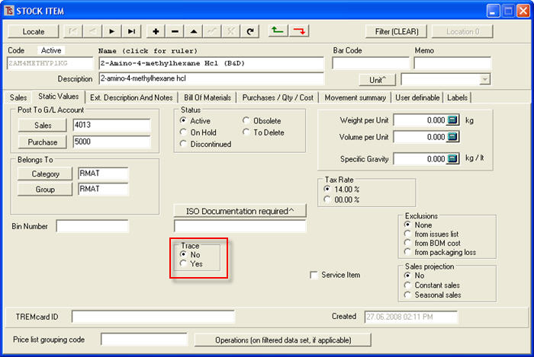
GOODS RECEIVED
When you purchase a traceable raw material, the batch numbers are entered when you receive the goods. These numbers may be the supplier’s number or a number that you generate in-house (or both). Multiple batch numbers on the same delivery note may be entered separated by a comma.
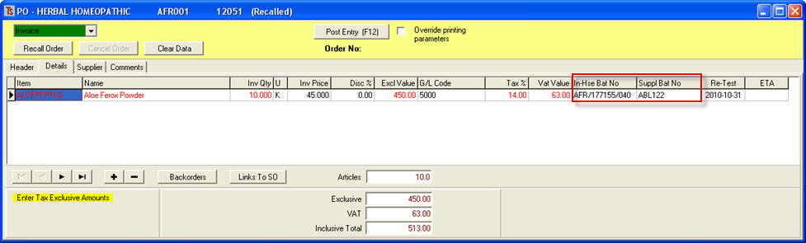

GOODS MANUFACTURED
When batches are manufactured, at the finished goods stage, clicking on the Batch Tracing button brings up a screen similar to that shown below where the operator may click on the field under either In Hse Bat No and/or on the field for Suppl Bat No in to bring up a drop-down list of available batch numbers of the used raw materials (and packaging if you want to trace these too).
Traceable materials are displayed in red.
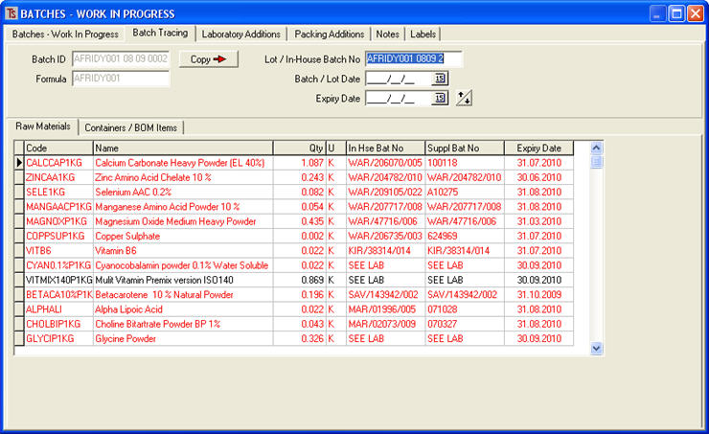

GOODS SOLD
When traceable goods are sold, the operator enters the batch numbers of the products supplied into the delivery note / invoice.
These batch numbers are generated by Alchemist.
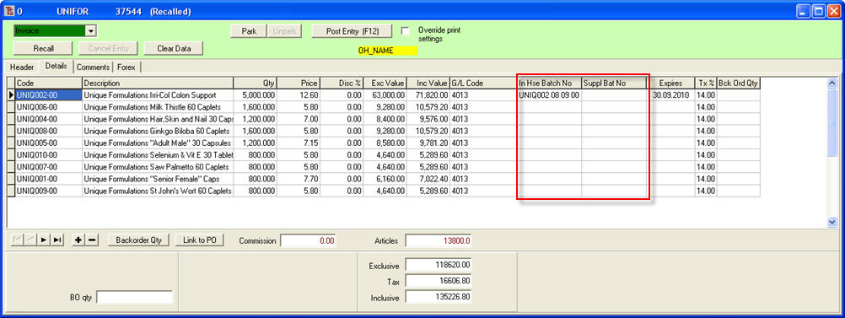
In the event that you are re-selling product that you have purchased for re-sale, you may also enter the supplier’s batch number(s).

TRACING
When you wish to trace an item, you go to [Stock][Reports][Alchemist] and click on the [Trace] button.
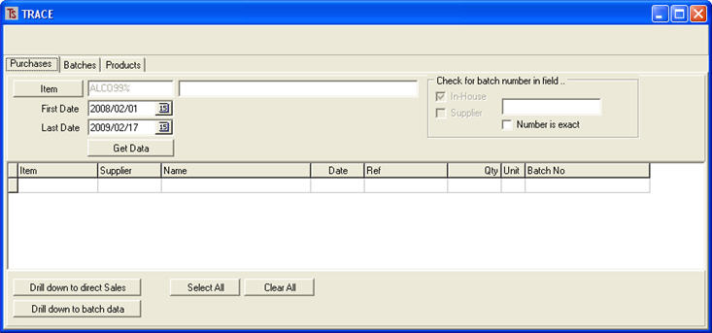

As you will see by studying the screen above, there are three tags.

Purchases tag; here you may enter a purchased product to be traced, select a date range or you may enter a batch number (which may or may not be 100% accurate – see (Number is exact) selection) and then click [Get Data].

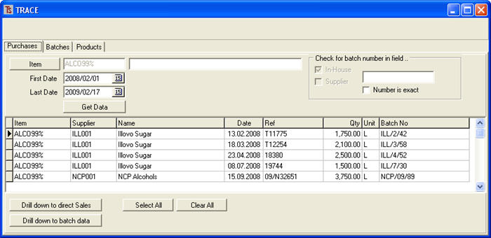

You can see from above that this provides information about who supplied the material selected, when it was supplied and the suppliers’ batch numbers.
From this screen, if the material was purchased and sold, then , by clicking the [Drill down to direct Sales] button, you would be able to see who had purchased the product, under what batch number, and when.
If the product is used in manufacturing, by selecting a particular batch of the raw material and clicking on the [Drill down to batch data] button, you will be able to see something likethis:
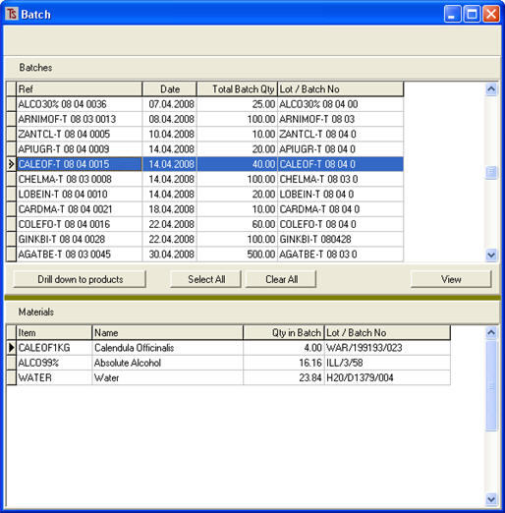

The above gives details of the batches in which this particular batch of raw material has been used.

Batches tag;

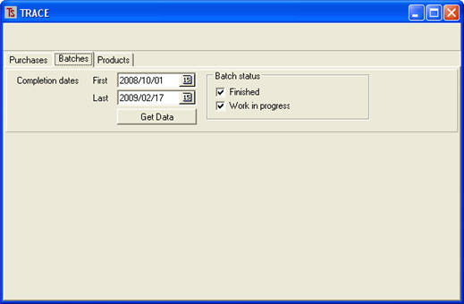

Here you select a date range and whether or not the batches are Work in Progress, Finished, or both.
When you select [Get Data] you will see something like:
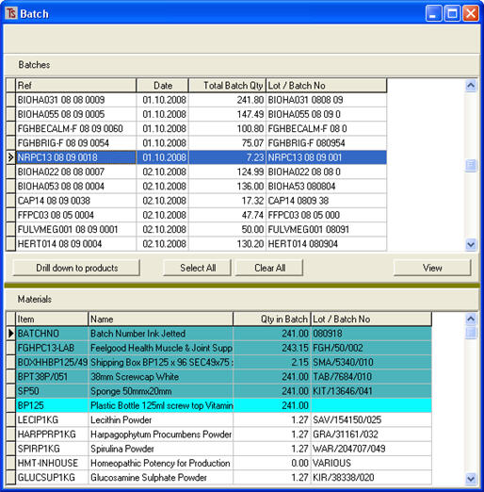

When you highlight a batch in the upper half of the screen, the lower half displays all of the materials used in that batch along with their batch numbers.
The Bill of materials items are shown in dark blue.
The container is shown in light blue
The materials used in the recipe or formulation are in light grey.

If you click on [View] you will see a report on the products with all of the materials used in those products, and their batch numbers.
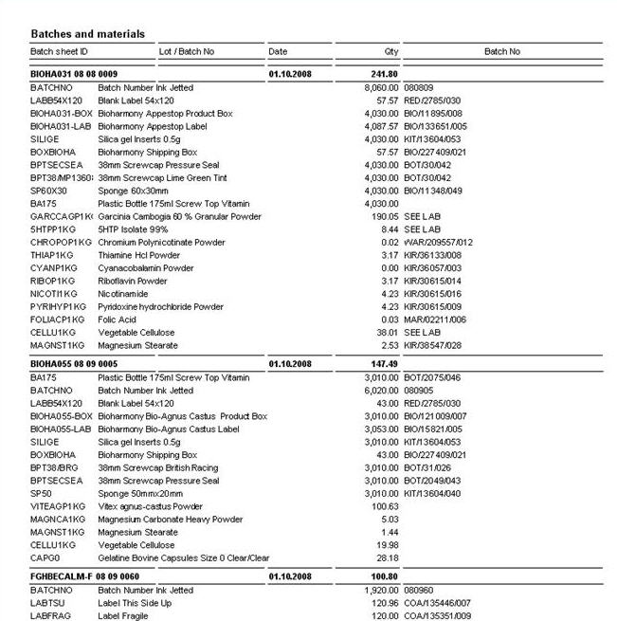

From here you may [Drill down to products]
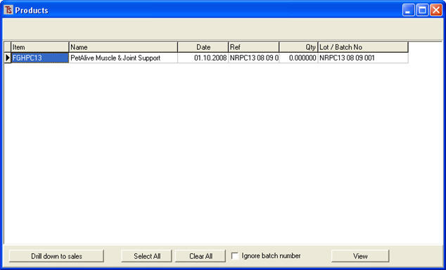

This shows details of the products produced.

Products tag;
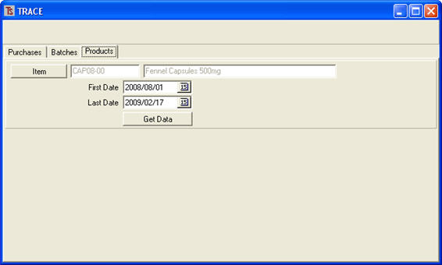

Here you can select a product and a date range and click [get Data].

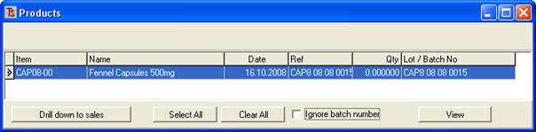
This gives information about the batches of products made within the date parameters.
If you then click [Drill down to sales] (note: you may need to select “ignore batch number” to get the information) you will see something similar to:

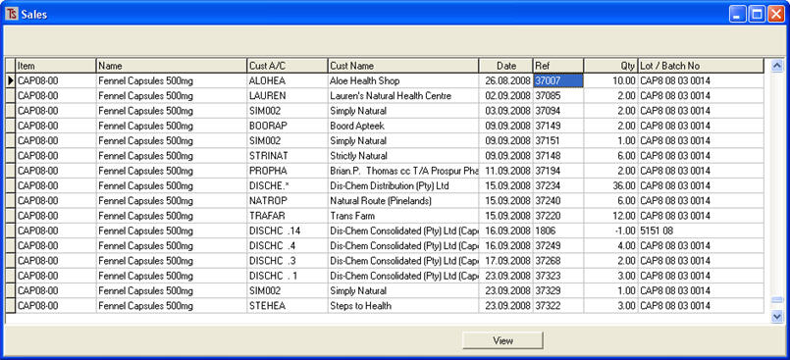

Clicking the [View] button will give a report on who had purchased the product, with batch numbers, invoice numbers and quantities.

You will see from the above that this is a very comprehensive batch tracing system that can track all items from receipt by your company through manufacturing to the sale of the end product to the customer.

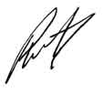

Phil Curtis

